On-The-Job Training (OJT) Report on
Lustro E-commerce at
Shivapuri Secondary School, Maharajgunj, Kathmandu

A Report Submitted
In the Partial Fulfillment of the Requirement for the Degree
Computer Engineering under Technical and Vocational Stream
Secondary Level Education (Grade - 10)

Submitted By:
Ashwin Sunuwar

Submitted To:
Department of Technical and Vocational Stream
National Examination Board
Sanothimi, Bhaktapur

Asar, 2083

CERTIFICATE OF APPROVAL
This is to certify that the On-the-Job Training (OJT) report entitled "Lustro E-commerce Platform" submitted by Mr. Ashwin Sunuwar, a student of Grade 10 at Shivapuri Secondary School, is an authentic record of the work carried out by him under my supervision and guidance during the academic year 2082/83 B.S.
This project demonstrates the practical application of modern web development concepts including frontend design, backend logic, and AI integration. The work was performed as part of the Grade 10 Computer Engineering curriculum and reflects a high level of dedication and technical skill.
This report is approved for the partial fulfillment of the requirements for the Grade 10 level in the Computer Engineering program under the Technical Stream for the academic year 2082 B.S is accepted.

.........................
External Evaluator
IT Instructor
Maharajgunj, Kathmandu, Nepal

CERTIFICATE OF ON THE JOB TRAINING
This is to certify that Mr. Ashwin Sunuwar, a student of Grade 10 at Shivapuri Secondary School, has successfully completed his On-the-Job Training (OJT) as part of the Computer Engineering curriculum under the Technical Stream for the academic year 2082B.S.
During the training period, he was actively involved in the design and development of the project titled "Lustro E-commerce Platform." His work included practical implementation of modern technologies such as frontend development, backend system design, database management, and basic AI integration.
Throughout the training, he demonstrated a strong sense of responsibility, dedication, and eagerness to learn. His ability to apply theoretical knowledge into practical work is commendable. He maintained good discipline and showed professional behavior during the entire training period.
We wish him success in his future academic and professional endeavors.

.........................
Supervisor
Er. Sagun Babu Adhikari
IT Instructor

DECLARATION
I, Ashwin Sunuwar, a student of Grade 10, hereby declare that the OJT report entitled 'Lustro E-commerce Platform' submitted to the Department of Computer Engineering, Shivapuri Secondary School, is my original work. The project was developed independently during my practice sessions at school, applying the principles of UI/UX design and programming I have learned in class.
I have followed all the institutional guidelines provided by the school and the National Education Board (NEB) during the preparation of this report. All information used from external sources has been duly acknowledged.
.........................
Mr. Ashwin Sunuwar
Shivapuri Secondary School
Maharajgunj-10, Kathmandu

PREFACE
The present report is the outcome of the On-the-Job Training (OJT) project titled 'Lustro - Luxury Watch E-commerce'. It is prepared as a key practical component of the Grade 10 Computer Engineering curriculum at Shivapuri Secondary School. The training was designed to provide students with hands-on experience in the rapidly evolving field of software development and digital commerce. This report reflects the practical exposure I gained while building a full-stack e-commerce solution. In an era where online shopping is dominated by commodity marketplaces, Lustro aims to deliver a curated, boutique-level experience that is both technically robust and user-friendly. The development process involved mastering React for the dynamic frontend, Django for the secure backend API, and building a rule-based concierge assistant to guide user decisions. This OJT has been a bridge between theoretical classroom concepts and the real-world application of engineering principles. Building Lustro allowed me to understand the complexities of real-world software, from database modelling to handling asynchronous operations, global state, and the complete order lifecycle. Beyond technical skills, it taught me the importance of UI/UX design in creating an elegant and accessible digital storefront. This experience has deepened my passion for technology and provided me with a solid foundation for my future career in computer engineering.

ACKNOWLEDGEMENT
This OJT report would not have been possible without the support and guidance of several individuals and institutions. First and foremost, I express my heartfelt gratitude to Er. Sagun Babu Adhikari for his continuous guidance, constructive feedback, and mentorship throughout the project. His expertise in modern software architecture and his encouragement helped me improve my technical skills and complete the project successfully.
I would also like to express my sincere gratitude to our respected Principal, Mrs. Sindhu Tuladha, for her valuable support, encouragement, and for creating a positive academic environment that made this training possible.
I would also like to thank Shivapuri Secondary School for providing the technical infrastructure and a supportive environment for this OJT. The Department of Computer Engineering has been instrumental in providing the foundational knowledge required to tackle such a complex project. I am grateful to my teachers for their constant supervision and for encouraging me to explore beyond the standard curriculum.
Finally, I extend my deepest gratitude to my parents and family for their constant support, motivation, and encouragement during this OJT. Their belief in my potential has been my greatest source of inspiration throughout this journey.

TABLE OF CONTENTS
Topic Page No.
CERTIFICATE OF APPROVAL ii
CERTIFICATE OF ON THE JOB TRAINING iii
DECLARATION iv
PREFACE v
ACKNOWLEDGEMENT vi
TABLE OF CONTENTS vii
ABBREVIATIONS ix
Chapter: 1 Introduction 1
1.1 Project Overview 1
1.2 Problem Statement 1
1.3 Project Objectives 1
1.4 Project Scope 2
Chapter: 2 OJT Workplace & Context 3
Chapter: 3 Technology & Technical Implementation 4
3.1 Technology Stack Details 4
3.2 Backend Data Models 4
3.3 Visual Showcase & UI Analysis 5
3.3.1 Advanced Landing Page Implementation 5
3.3.2 Featured Products Section 6
3.3.3 Category Discovery System 6
3.3.4 Advanced Filtering & Sorting 7
3.3.5 Instant Full-Text Search 7
3.3.6 Lustro Concierge Intelligence Integration 8
3.3.8 Detailed Product Architecture 9
3.3.9 Logic-Heavy Multi-Store Cart 9
3.3.10 Secure Multi-Step Checkout 10
3.3.11 Customer Feedback & Review System 10
3.3.12 Responsive Navigation & Meta Links 11
Chapter: 4 OJT Summary & Learning 12
4.1 Observations & Analysis 12
4.2 Technical Skills Acquired 12
Chapter: 5 Conclusion, Recommendation & Suggestion 13
5.1 Conclusion 13
5.2 Limitations 13
5.3 Future Enhancements 14
5.4 Recommendations 14
5.5 Suggestions 14
References 14

ABBREVIATIONS
OJT : On-the-Job Training
CRM : Customer Relationship Management
API : Application Programming Interface
JWT : JSON Web Token
SPA : Single Page Application
DRF : Django REST Framework
ORM : Object-Relational Mapping
LLM : Large Language Model
UI/UX : User Interface / User Experience

Chapter: 1 Introduction

1.1 Project Overview
Lustro is a full-stack luxury watch e-commerce platform that curates the world's most exceptional timepieces. It was designed to bring a private-boutique shopping experience online, combining an immersive 3D home experience, a concierge chat assistant, verified collector reviews, and a complete commerce workflow. While global platforms focus on wide-scale logistics, Lustro focuses on craftsmanship, curation, and personalized service for watch enthusiasts and collectors.
The project was conceived as a Grade 10 OJT project to demonstrate how modern web technologies can be combined to build a production-grade commercial application. Lustro combines an immersive three.js 3D hero scene, a data-rich catalogue of 61 timepieces across 14 brands and 6 categories, JWT-secured accounts, and a specialized 'Lustro Concierge' chat assistant that recommends timepieces by brand, budget, and style.

1.2 Problem Statement
The online luxury watch market faces several digital barriers:
- Discovery Gap: Luxury timepieces are difficult to browse online; traditional stores offer limited photography, and generic retailers cannot convey rarity, provenance, or collector context.
- Generic Browsing: Standard e-commerce platforms treat watches like commodity goods, with weak filtering and no specialist guidance for features such as movement type, caliber, power reserve, and water resistance.
- Lack of Personalized Guidance: Shoppers often need expert advice matching a specific brand, budget, and style, which conventional recommendation engines fail to provide.

1.3 Project Objectives
The primary objectives of the Lustro project were:
- To build a responsive, visually rich frontend using React, TypeScript, Tailwind CSS, and three.js for a 3D storefront experience.
- To implement a secure and scalable backend using Django and the Django REST Framework with JWT authentication.
- To integrate a rule-based concierge chat assistant that provides instant, data-driven watch recommendations.
- To deliver full commerce workflows including cart, coupons, checkout, order tracking, wishlist, compare, and reviews.

1.4 Project Scope
The project scope covers the end-to-end development of a luxury watch e-commerce platform. This includes user authentication (JWT), product listing, filtering and search, brand and category management, reviews with verified purchases, cart, wishlist and compare features, coupon-based checkout, order tracking and cancellation with stock restore, and a Django admin interface. The scope is limited to a functional prototype suitable for local testing and school demonstrations.

Chapter: 2 OJT Workplace & Context
The On-the-Job Training (OJT) was conducted in the Computer Engineering Department of Shivapuri Secondary School, Maharajgunj, Kathmandu, during the academic year 2082/83. The training environment was designed to provide practical exposure to software development, allowing students to apply classroom knowledge in a real-world project setting. The school provided the necessary computer systems, internet access, and technical resources required for the successful completion of the project.
The development of the Lustro platform followed a structured workflow based on Agile development principles. The project was divided into manageable tasks such as backend data modelling, REST API development, frontend page implementation, state management, checkout and order processing, and the concierge chat engine. Regular testing, debugging, and documentation review were carried out throughout the development process to ensure system reliability and performance.
During the OJT, I gained valuable experience in full-stack web development using React, TypeScript, Django, and Django REST Framework. The project provided hands-on exposure to database management, API development, responsive user interface design, and AI-powered features. This practical learning environment enhanced both my technical knowledge and problem-solving abilities, helping me understand the complete software development lifecycle.

Chapter: 3 Technology & Technical Implementation

3.1 Technology Stack Details
The Lustro platform is built using a decoupled architecture, ensuring that the frontend and backend can evolve independently. The technical stack includes:
- Frontend: React 19 with TypeScript. TypeScript was used to ensure type safety, reducing bugs in complex state management scenarios. Vite was used as the build tool for fast development cycles, Tailwind CSS v4 for styling, and three.js with GSAP for the immersive 3D home scene. Zustand and TanStack Query manage global state and server data.
- Backend: Django 6 with the Django REST Framework. Django's powerful ORM was used for database management and DRF serializers serve JSON data to the React frontend. JWT authentication is handled by SimpleJWT, and the database is SQLite in development with PostgreSQL in production.
- AI Layer: A rule-based concierge engine that parses natural-language requests for brand, budget, and style, and answers from live database queries - delivering instant, up-to-date recommendations without heavy server-side inference.

3.2 Backend Data Models
The backend architecture is centered around several key models:
- Watch Model: The core catalogue entity storing titles, slugs, prices and discount prices, movement type, caliber, power reserve, case dimensions, materials, water resistance, stock levels, and featured flags such as 'is_featured' and 'is_trending'.
- Brand, Category and Collection Models: Allow structured organization of timepieces - essential for the filtering system used in the frontend - along with descriptions, logos, and cover images.
- Order, OrderItem and Coupon Models: Implement the full commerce flow including order numbers, payment methods (card or cash on delivery), payment status, shipping details, gift wrapping, discount tracking, and stock reservation and release on cancellation.
- Review Model: Implements a verified purchase system where users can leave ratings and text feedback to build community trust, alongside Conversation and Appointment models for the concierge chat and boutique bookings.

3.3 Visual Showcase & UI Analysis
The following sub-sections present each major module of the Lustro platform with screenshots. Each component was designed with user experience as the primary focus, ensuring that the platform remains accessible and intuitive for watch enthusiasts and first-time buyers alike.

3.3.1 Advanced Landing Page Implementation
The Lustro landing page opens with an immersive three.js 3D watch scene driven by GSAP scroll choreography, designed for high impact and clear navigation.
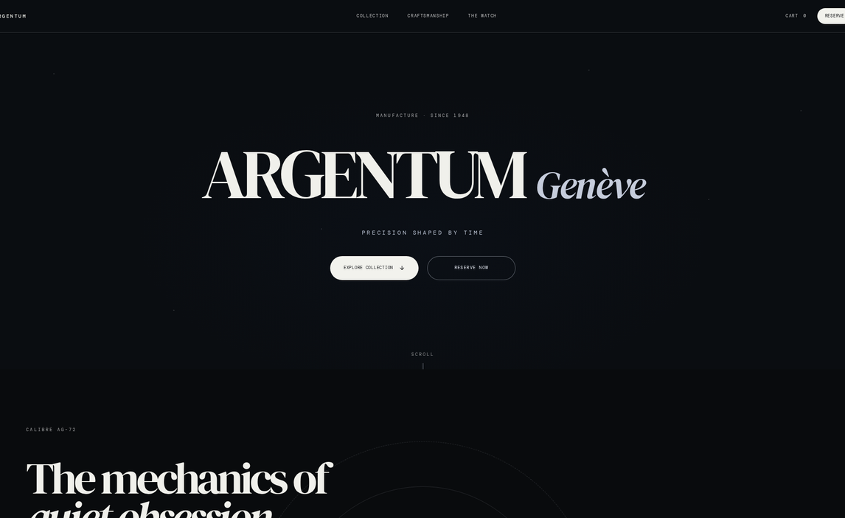

3.3.2 Featured Products Section
The Featured Products section showcases high-priority timepieces using a curated grid layout.


3.3.3 Category Discovery System
The catalogue provides structured browsing by brand, category, and collection, with dedicated brand detail pages.
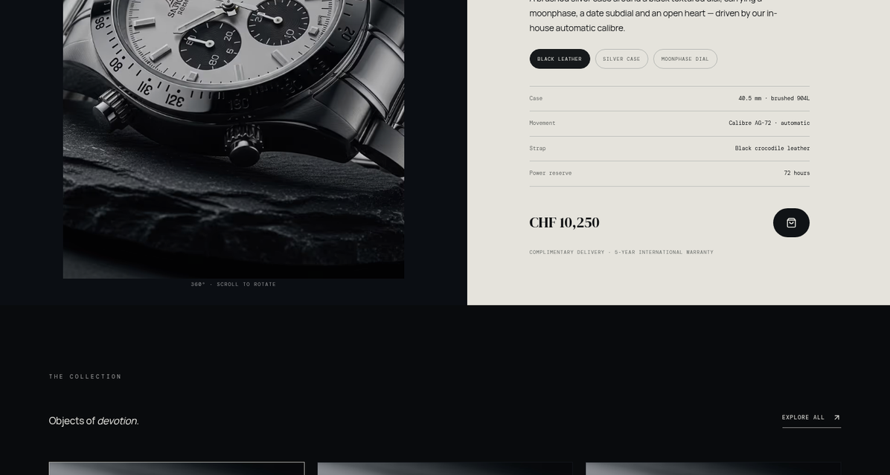

3.3.4 Advanced Filtering & Sorting
The filtering system allows users to narrow down the catalogue by brand, category, movement type, gender, price range, stock status, and sale items, with sorting and grid/list views.
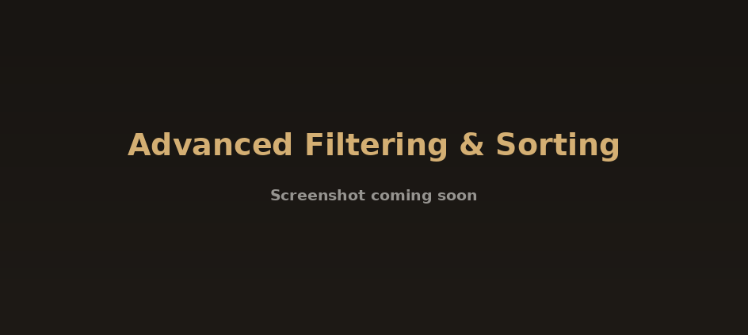

3.3.5 Instant Full-Text Search
The shop features an instant, as-you-type search over the full catalogue, with URL-driven, shareable filter state.


3.3.6 Lustro Concierge Intelligence Integration
The Lustro Concierge chat assistant represents a sophisticated rule-based engine that interprets brand, budget, and style from natural language and answers with live product data.

Comprehensive Django Admin Dashboard
The Django admin dashboard is a comprehensive management suite covering watches, brands, orders, coupons, waitlists, newsletters, and chat appointments.


3.3.8 Detailed Product Architecture
The product detail page presents a gallery, full technical specifications, verified collector reviews, related pieces, and a waitlist for sold-out timepieces.
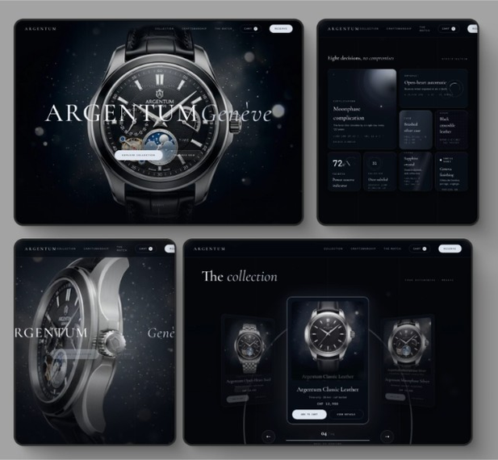

3.3.9 Logic-Heavy Multi-Store Cart
The cart supports quantity management, save-for-later, shipping and totals, and integrates with the wishlist and compare (max 3) features.
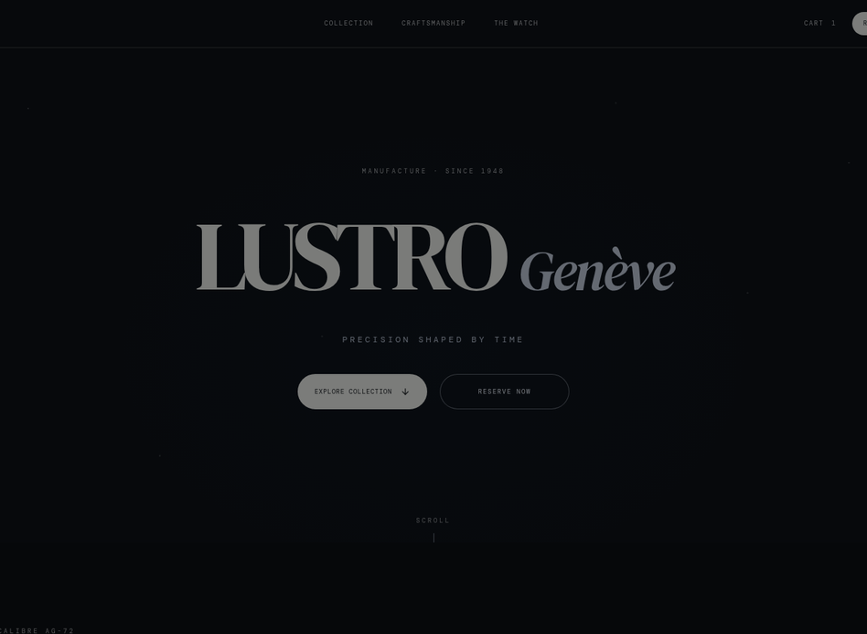

3.3.10 Secure Multi-Step Checkout
The checkout page is a multi-step process - address, shipping, payment (card or cash on delivery) - with coupon support and stock reservation.


3.3.11 Customer Feedback & Review System
The reviews section builds social proof and trust through verified purchase badges.


3.3.12 Responsive Navigation & Meta Links
The responsive footer provides essential navigation links, social media integration, newsletter subscription, and company information.
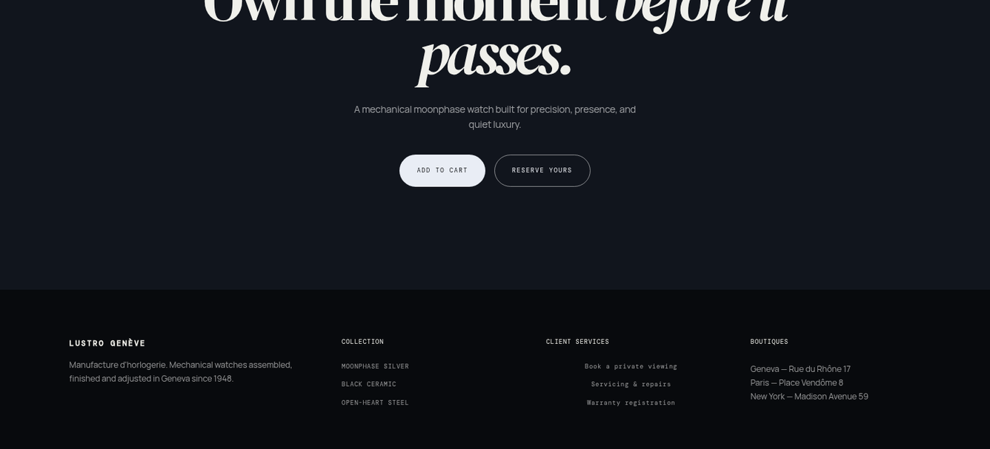

Chapter: 4 OJT Summary & Learning

4.1 Observations & Analysis
Throughout the OJT, I observed how modern web development is shifting towards client-side interactivity and instant feedback. By moving complex logic such as filtering, search, and cart state to the frontend, a snappier user experience is achievable. I also analysed how critical slug-based routing is for SEO and user readability, which led to the implementation of automatic slug generation in Django using the 'slugify' utility, and how a data-ingestion scraper with deduplication, normalization, and licensing checks keeps the curated catalogue clean.

4.2 Technical Skills Acquired
Working on Lustro, I have mastered several key skills:
- Full-stack Integration: Connecting a Django REST backend with a Vite-powered React frontend, including JWT authentication and TanStack Query data fetching.
- Advanced Styling and Animation: Using Tailwind CSS for responsive, theme-aware interfaces plus three.js, GSAP, and Framer Motion for motion design.
- Commerce Logic: Designing multi-step checkout, coupon and stock-reservation flows with database transactions.
- Version Control: Maintaining a clean development history and managing different features via Git.

Chapter: 5 Conclusion, Recommendation & Suggestion

5.1 Conclusion
The Lustro project has successfully achieved its goals of building a functional, full-stack luxury watch e-commerce platform with a curated catalogue, immersive 3D storefront, concierge assistant, and complete commerce workflows. For a Grade 10 student, this OJT has been a transformative experience, bridging the gap between school-level ICT and professional software engineering. Lustro stands as a proof-of-concept for how modern web technology can deliver a boutique shopping experience online.

5.2 Limitations
Although the Lustro OJT project was highly beneficial, certain limitations were encountered during its development:
- Prototype Scope: The project was limited to a functional prototype; full production deployment with real payment gateway integration was not achieved within the OJT period.
- Connectivity Issues: Intermittent internet connectivity at school occasionally disrupted live API testing and deployment workflows.
- Time Constraints: Limited OJT duration prevented deeper exploration of advanced performance optimization, image optimization pipelines, and more extensive test coverage.

5.3 Future Enhancements
The Lustro platform has strong potential for future development. The following enhancements are planned:
- Real-time Notifications: Integrating WebSockets to notify customers and administrators of order status changes instantly.
- Payment Integration: Connecting real payment gateways for card payments, alongside shipping-tracking APIs.
- Enhanced Concierge AI: Extending the rule-based engine with a large language model trained on the catalogue to provide even more conversational and accurate recommendations.

5.4 Recommendations
Based on the OJT experience with Lustro, the following recommendations are offered to improve future projects:
- Better Infrastructure: Schools should provide stable, high-speed internet and dedicated lab computers to support full-stack development OJT projects.
- Extended OJT Duration: Allocating more time for OJT would allow students to implement more advanced features, conduct thorough testing, and refine documentation quality.
- Regular Workshops: Conducting regular workshops on modern web technologies, version control, and deployment would better prepare students for real-world development projects.

5.5 Suggestions
From the Lustro OJT experience, the following suggestions are offered to future trainees and institutions:
- Learn Fundamentals First: Future trainees should ensure strong foundational knowledge of HTML, CSS, JavaScript, and Python/Django before starting a full-stack OJT project.
- Maintain a Daily Logbook: Students should keep a daily development log to track progress, document bugs, and record learning milestones throughout the OJT period.
- Use Version Control from Day One: Adopting Git and GitHub from the very beginning of the project ensures clean commit history, easier collaboration, and a professional portfolio for future opportunities.

References
1. Django REST Framework (Backend API): https://www.django-rest-framework.org/
2. React (Frontend Library): https://react.dev
3. Three.js (3D Graphics): https://threejs.org

